Jumde Rushikesh S.
B.E.(Civil)**
E-mail: rushikeshjumde86@gmail.com
Mobile: +91-7709456952/+91-7972479474
Objective

To work to the best of my ability and face any challenges.

To work as a dynamic professional in an environment that would provide opportunity to utilize my skills and strength.
Educational Details:

Presently pursuing B.E. in Civil Engineering.

1. Bachelor of Engineering
Institution | PROF RAM MEGHE COLLEGE OF ENGINEERING
Stream | Civil Engineering
University | Amravati University
Percentage | 65%
Year of completion | 2013-2017

2. Higher Secondary School Certificate Examination
Institution | RURAL INDEPENDENT INSTITUTE
Stream | Physics, Chemistry, Mathematics.
Board of Education | State Board
Percentage | 68.75%
Year of completion | February 2013

3. Secondary School Certificate Examination
Institution | RAMKRISHNA KRIDA VIDHYALAYA
Board of Education | State Board
Percentage | 72.18%
Year of completion | March 2011

Strengths:

Good at interpersonal skills-Calmer, Positive and Much more respectful towards the people that I worked with.
Flexibility to new environment, customs, cultures. Articulate with excellent interpersonal skills to manage external/internal interactions.
Learning new things quickly and adapting towards changes.

Presented the seminar on “SOIL STABILISATION USING RICE HUSK ASH & LIME” in final year of engineering.

Seminar Presented:
Computer Knowledge

Operating System | Windows
- | -

Project Detail:

TITLE : “SOIL STABILISATION USING PHOSPOGYPSUM & FLY ASH”

Description
In the world today there is a need of increase the stabilisation of soil. In order to do so my project deals with development of a new stabilising agent & improve quality of b.c. soil.

Extra curricular activities

Had a participation in BASKETBALL UNIVERSITY LEVEL.
Had a participation in -
Personal Details:

Date of birth & Age : 18-06-1996, 21 years
Father’s Name : Mr. Sanjay Jumde
Linguistic Abilities

To Speak : English, Hindi Marathi.
To Read & Write : English, Hindi, Marathi.
Declaration:

I here by declare that the information furnished above is correct to the best of my knowledge.

Station: Amravati.
Yours sincerely,
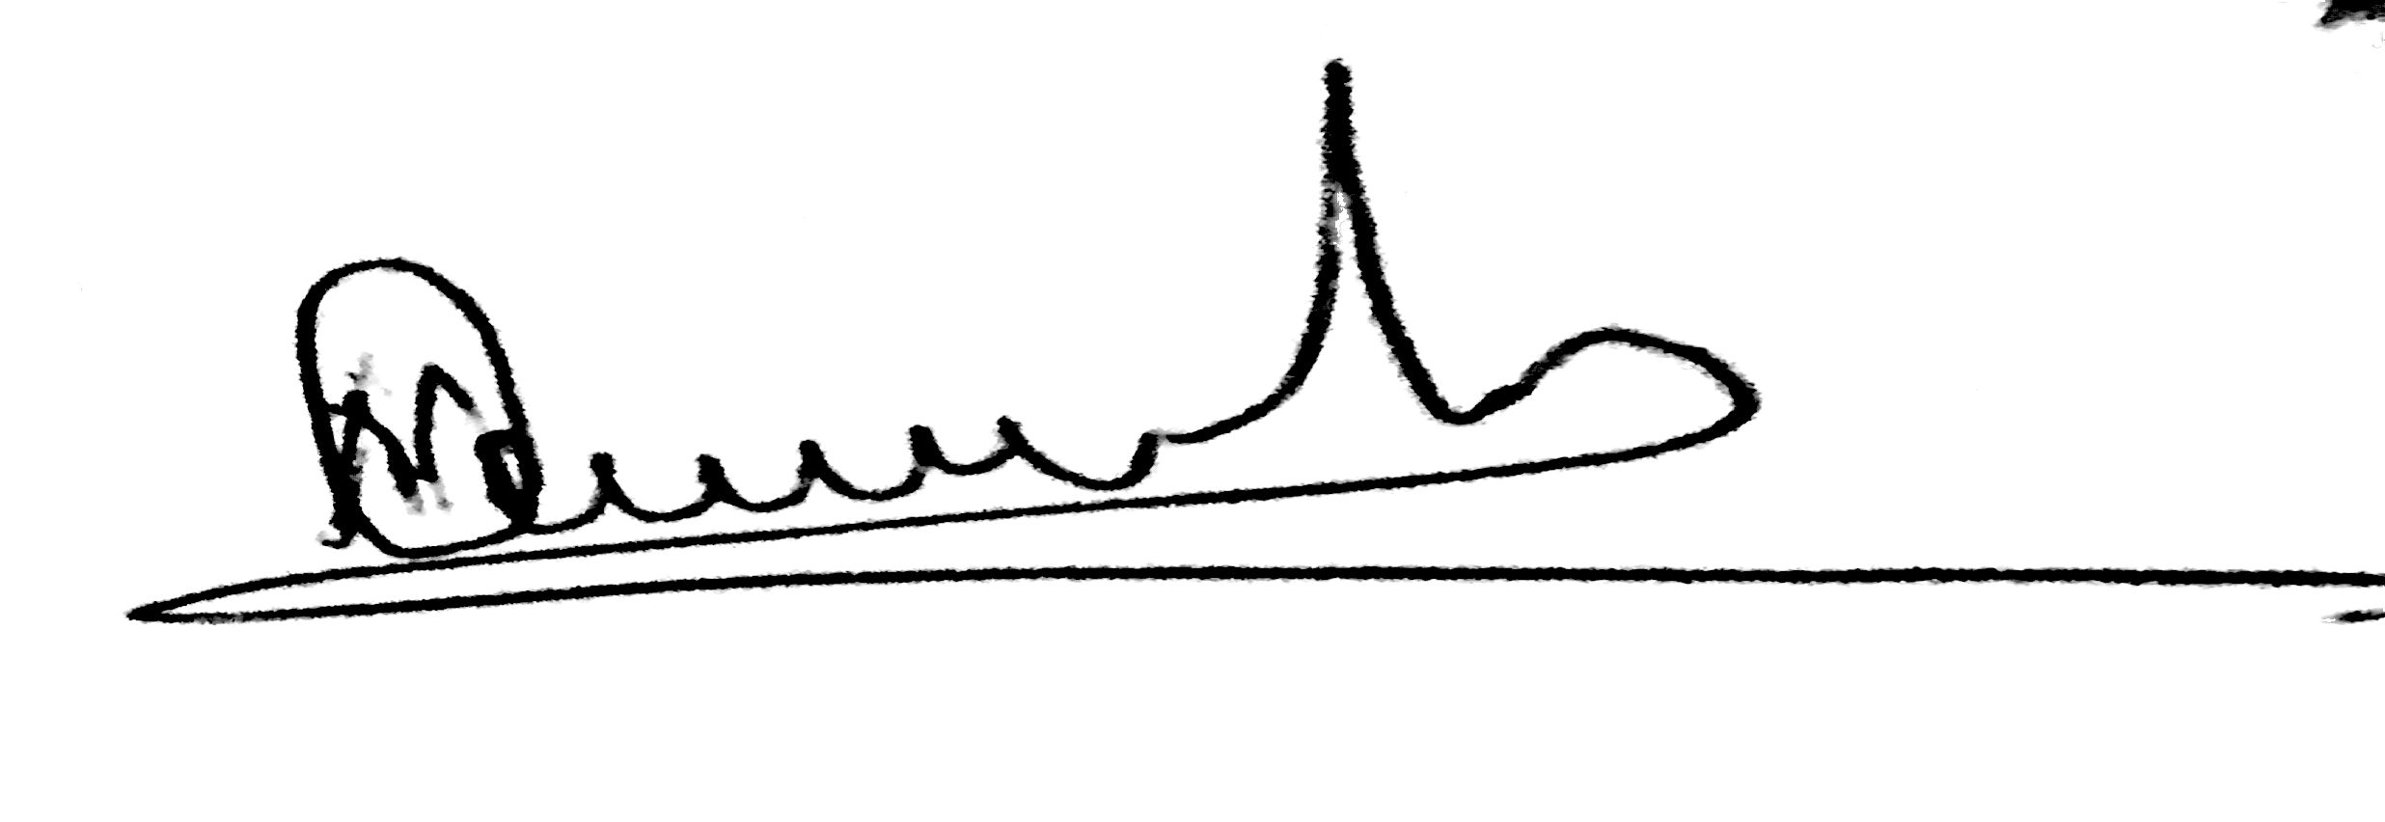
Jumde Rushikesh S.

